6th March 2023
Dear Parents/Carers,
As you are aware Year 9 students are soon to be selecting their option subjects which they will go on to study throughout Year 10 and 11.
In order to support students, parents and carers during this process we will hold a ‘marketplace’ style Options Evening. Each GCSE subject will be represented. The Head of Department and subject staff will be available to talk to parents and students regarding their subject. Information will be provided regarding the course content, assessment, wider skills and the opportunity explore career links.
The rearranged options evening is 14th March 6-8pm.
On the evening you will receive a pack containing a guide to the evening, a map of subject locations, the options booklet and the form to be handed in once options have been selected. Option selection forms will need to be returned by Friday 31st March.
To further inform students, Year 9 have already had an assembly outlining the process of selecting their options
Please return the slip below to Year 9 form tutors or directly to Mrs Lancett
If you have any queries, please contact the school or email myself on slancett@stm.srscmat.co.uk
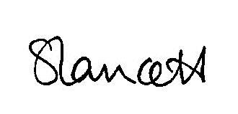
Kind Regards,

Mrs Lancett
Deputy Headteacher
……………………………………………………………………………………………………………………………………………………………………………..

Year 9 Options Evening
We will/ will not be attending the Options Evening on Tuesday 14th March. (Please circle)
Name of child: ______________________________________ Form group:______________________
Signed (parent/ carer):_______________________________________

