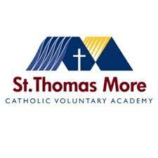Year 11 Revision programme 2022-2023

|  |  |  |  |  |
| --- | --- | --- | --- | --- |
| **7.55-8.25: Revision breakfast:**  Students are welcome to attend with a personal revision focus. Additional revision materials will be available.  Light refreshments available for those revising or completing coursework. | | | | |
| **During Tutor time:**  Selected groups will be working in Maths/ Sci/ English to boost grades. | | | | |
| Monday | Tuesday | Wednesday | Thursday | Fri |
| Lunchtime sessions | | | | |
| Music  Art | Music  Art  RE (WK2)  Maths drop in (specified group) | Music  Art (WK 1 only)  DT | Music  DT  RE (WK1)  Geog (drop in) | Music  Art |
| Afterschool sessions 3.15- 4.15 | | | | |
| Maths  Art (after Maths 4pm start) | English (WK1)  Maths (selected students only)  Art (WK1 after Eng 4pm start)  Spanish  DT | Science (physics and chemistry)  Food tech | History  PE (ICT suite) | Science (Biology)  Geog |
|  | | | | |
| **3.15-4.00 Period 6 revision club for those not involved in subject specific sessions.**  Students not attending subject specific revision sessions are welcome to work on thew stage or in ICT suite 115.  Students should come with a personal revision focus. Additional revision materials will be available.  Period 6 revision club is optional and is there for students wishing to revise/ work at the end of the school day. | | | | |