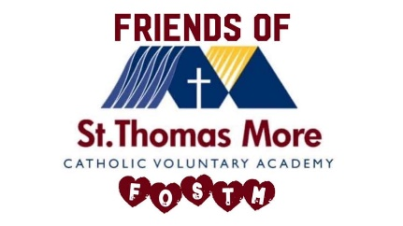

**This is a letter from our PTA - FOSTM**

**Dear Future STM Parents and Carers,**

A very warm welcome to the St Thomas More family!

We are *Friends of St Thomas More (FOSTM)* — a dedicated group of parents and carers who work closely with the school to create fun, enriching experiences for our children and raise vital funds to support the school community.

Over the years, we’ve organised a wide range of events such as cake and bake sales, tombolas, fayres, film nights, and more. Thanks to the generous support of parents like you, we’ve raised money for outdoor benches, mobile planetarium visits, concerts, equipment, and other exciting opportunities for our students.

We are always looking for new members to join us! Whether you have creative ideas for events, skills in advertising, time to volunteer, or simply an interest in joining our friendly meetings, we’d love to welcome you on board.

If time is tight but you’d still like to contribute, setting up a small monthly donation is another great way to support FOSTM. Every little bit helps, and it all goes straight back into benefiting our school.

**Donation details:**  
Sort code: 08-92-99  
Account number: 65881992  
Account name: Friends of St Thomas More

For more information or to get involved, please email us at **enquiries@stm.srscmat.co.uk** with **"FOSTM enquiry"** in the subject line.

We truly believe that when parents and carers get involved, great things happen — and we’d love for you to be part of that.

Looking forward to hearing from you!

**Kind regards,**  
*Friends of St Thomas More (FOSTM)*