**At St Thomas More, we are proud to wear our uniform. It contributes to our sense of belonging and our aspiration to #BeMore.**

## Uniform

Our Mission Statement states that we have “expectations of the highest possible standards in all things for all pupils…”

At St Thomas More, we are proud to wear our uniform. It contributes to our sense of belonging and our aspiration to #BeMore

Our school uniform is functional for everyday use, promotes a community identity and helps keep pupils safe. Our school uniform also promotes equality, as the same standards apply for all pupils.

Most items of uniform can be purchased from high street stores, however items in bold can only be purchased from our uniform suppliers:

[ClassworX | Your Uniform Store | School Uniform Supplier In Macclesfield](https://classworx.co.uk/)

|  |  |
| --- | --- |
| School tie | **School tie (clip-on for all years)** |
| Shirt | White plain shirt (tucked into waistband of trousers/skirts)  After May half-term short sleeved shirts may be worn. |
| Trousers | Plain, black trousers (jeans/cords/canvas/linen/skinny trousers or leggings are not acceptable) |
| Skirt | **Black, box pleat logo skirt – available from ClassworX** |
| Jumper | **School maroon plain v-neck jumper with school logo (Key Stage 3 pupils)**  **School black plain v-neck jumper with school logo (Key Stage 4 pupils)** |
| Socks/Tights | Plain black or charcoal school socks. Pupils should not wear white socks. Black opaque tights (not patterned). |
| Shoes | Black flat sensible shoes with no logo/motif (not boots, trainers*, canvas or flip flops) |
| Shorts | After May half-term pupils can wear black tailored shorts as part of the summer uniform. No other shorts are permitted. |
| Hair | Hair should be neat and tidy without decorative attachments. Extreme styles, unnatural hair colours, tramlines, shaved shapes in the hair or eyebrows are not permitted. |
| Make-up | If make-up is worn, it should be moderate and unobtrusive. False eyelashes, nail polish, false/acrylic nails and teeth gems are not permitted. |
| Jewellery | The only jewellery permitted is a wristwatch, a light chain crucifix (tucked inside the shirt), a single stud earring, a set of plain stud earrings, one in each ear, worn in the lower ear lobe. No other piercings/jewellery is permitted. NB all jewellery must be removed for PE lessons. |
| Mobile Phones and other electronic devices. | There is no need to bring electronic devices into school. Mobile phones must be switched off (not just on silent) and remain in the pupil’s bag whilst on the school site. If mobile phones are seen or heard, they will be confiscated. If a pupil has a mobile phone, visible on the school site, it will be confiscated as per the Mobile phone policy. The same applies to gaming devices, earphones, speakers and any other music device. |
| PE Kit | **Logo PE Polo**  **Logo PE Hoodie**  **Logo PE shorts**  Plain black base layers (optional)  Black football socks (outdoor PE)  White ankle socks (indoor PE)  Trainers (NOT black soles) - no pumps, canvas or fabric shoes.  **Logo PE leggings (optional)**  Plain black tracksuit bottoms (to be worn at the discretion of the teacher in Winter)  Football boots are highly recommended for outdoor football for both boys and girls |

*Please note that we do allow Nike Air Force 1s (with the tags removed) to allow for a shoe option that is suitable for both normal school uniform and PE uniform.

**In all cases, the Headteacher has the discretion to decide what is and is not allowable under the policy.**

**The Role of Parents**

We ask all parents who send their children to our school to support the school uniform policy. We believe that parents have a duty to send their children to school correctly dressed and ready for their daily schoolwork. One of the responsibilities of parents is to ensure that their child has the correct uniform and equipment, and that it is clean and in good repair.

**Parental Requests**

If any parent would like the school to modify the uniform and equipment policy, they should make representation, in the first instance, to the Headteacher. The school welcomes children from all backgrounds and faith communities. If there are serious reasons, for example on religious grounds, why parents want their child to wear clothes that differ from the school uniform, the school will look sympathetically at such requests.

**The Role of Governors**

The governing body implements the school uniform and equipment policy. It considers all representations from parents regarding uniform and liaises with the Headteacher to ensure that the policy is implemented fairly and with sensitivity. It is the governors’ responsibility to ensure that the school meets all regulations concerning equal opportunities. Governors ensure that the school uniform and equipment policy helps children to dress sensibly, in clothing that is hardwearing, safe and practical and equips children ready to learn.

## Uniform purchase

Uniform can be purchased from ClassworX in Macclesfield:

CLASSWORX,

KING EDWARD RD,

MACCLESFIELD

SK10 1AP

<https://classworx.co.uk>

01625 500552

## School equipment

Every student is expected to provide the following essential items of equipment for every lesson. It is important to ensure pencil cases are replenished throughout the year to account for loss/breakages/ink running out etc.

Backpack/Bag – large enough to carry the following:

* Headphones
* PE kit when appropriate
* Water bottle
* Pencil case containing at least the following:
* Compass
* Felt tip pens or coloured pencils
* Glue stick
* Pencil
* Pencil eraser
* Pens – 2 black or blue pens, a purple pen and a red pen
* Protractor
* Ruler – 30cm
* Scientific Calculator (ideally Casio)
* Scissors

Textbooks and specialised equipment will be used on loan and students will be required to pay for any loss or damage to school property. This includes library books.

Students are responsible for ensuring they bring their equipment and correct exercise books with them each day.

My Uniform and Equipment Checklist for Year 7

* Tie(s)
* 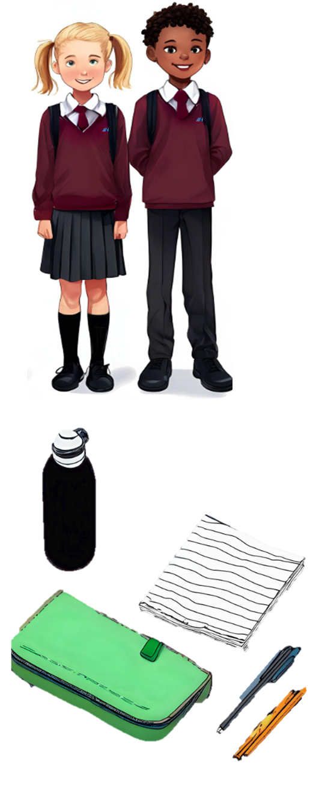Shirt(s)
* Skirt/Trouser(s)
* Maroon jumper
* Shoes
* School Bag
* Pencil Case
* Water bottle
* 2 black or blue pens
* Red pen
* Purple pen
* 30cm ruler
* Pencil
* Eraser
* Sharpener
* Compass
* Protractor
* Felt tips/coloured pens
* Glue stick
* Scissors
* Scientific calculator (ideally Casio)